**Project Development Phase**

**Project Development Delivery of Sprint 3**

|  |  |
| --- | --- |
| Team ID | PNT2022TMID50825 |
| Project name | Personal Expense Tracker Application |

Flow chart:

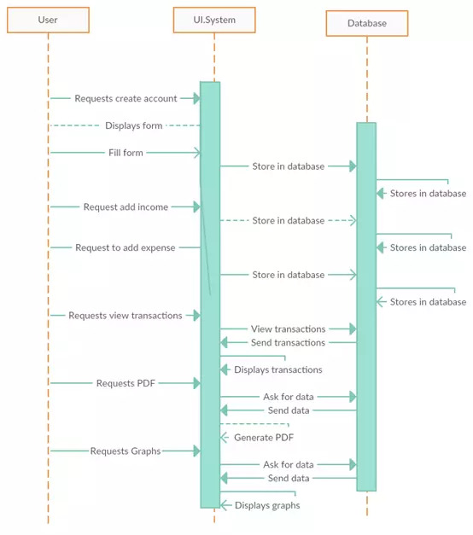

**Concept:**

* To build a platform for the users who want to monitor their own expenses.
* To implement a notification alert system for the expense limitation.
* To find the reliable system for the users.
* To increase the user’s ability to limit their expenses.

Advantages:

* It is auser-friendly application.
* It will help people to limit the expenses.

Disadvantages:

* + - It cannot automatically add the expenses.
    - It requires an active internet connection.